DUNOON PRIMARY ELC HANDBOOK 2024- 2025


Dunoon ELC- where I’m free to be me!

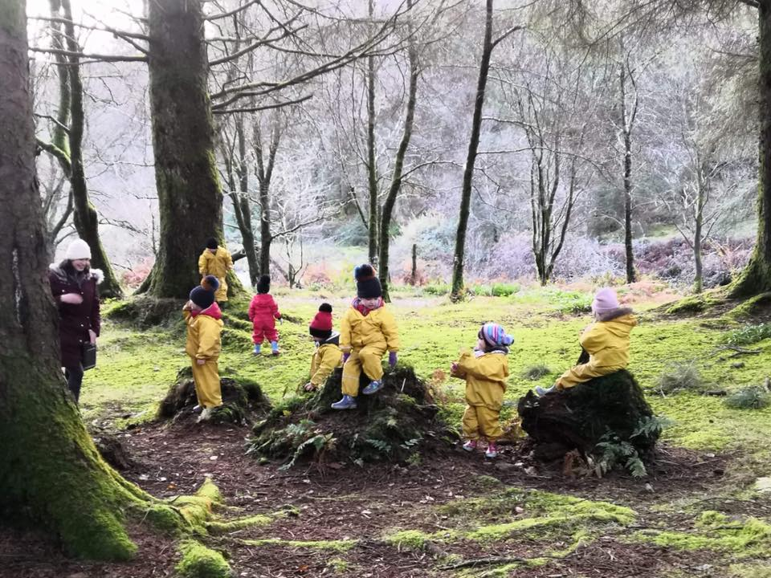

Dunoon Primary School – Early Learning and Childcare
Hillfoot St
Dunoon
PA23 7DR
(01369) 70 4159
DUNOON ELC- Where I’m free to be me!

Our vision at Dunoon Primary School ELC is to provide a nurturing, inclusive, welcoming nursery where children come to have fun and are confident to lead their own learning. We strive to develop positive relationships with your child and family and encourage parents and carers to take an active role within their child’s nursery life.

At Dunoon Primary School ELC, our values are:
- Curiosity
- Kindness
- Nurture
- Respect
We strive to have these values embedded into our daily life practice and provide children with a stimulating and inviting nursery that enables them to be explorers of their own learning and provide them with opportunities to be creative.

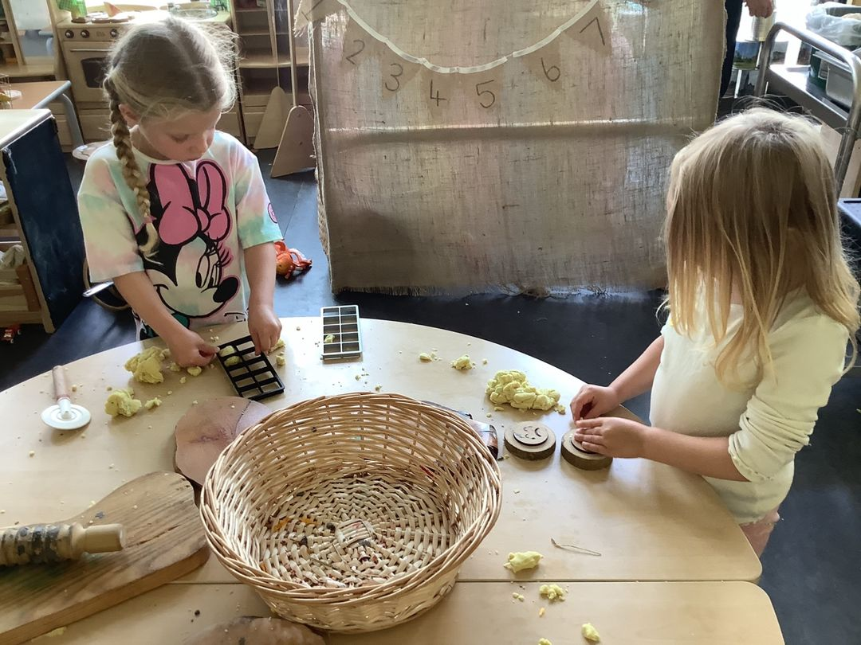
CONTACT US

To speak to your child’s Key worker, or to report absence, please use the contact details below.

Dunoon
Tel: 01369 704159
Email: enquiries@Dunoon.argyll-bute.gov.uk
Facebook: Dunoon Primary School

STAFF

Head Teacher Brenda Reid

Principal Teacher Rachael Bryant
Oversees Nursery

Lead Practitioner Holly Macdonald

Practitioners Sharon Waddell

Jilly Headrick

Lauren Scott

Modern Apprentice Jessica Campbell

ASN Assistant Alison Gladwell

Clerical Assistants Lindsey McPhail

Amy Brawley

Janitors Davie Hynds

Jim Devlin

Opening Hours

Nursery hours operate from 8:50 to 2:50. During the nursery day your child will have the opportunity to experience a wide range of different play-based activities, such as construction and small world, role play and imaginative play, water, sand, mark making, songs, rhymes and stories, as well as lots of opportunities for outdoor learning.

SNACKS

Two healthy snacks are provided each day; we serve a selection of fruit, vegetables, crackers, bread and cheese. Milk and water are always available. We encourage the children to plan the snack menu and help us to set up, prepare and tidy away snack.

LUNCH

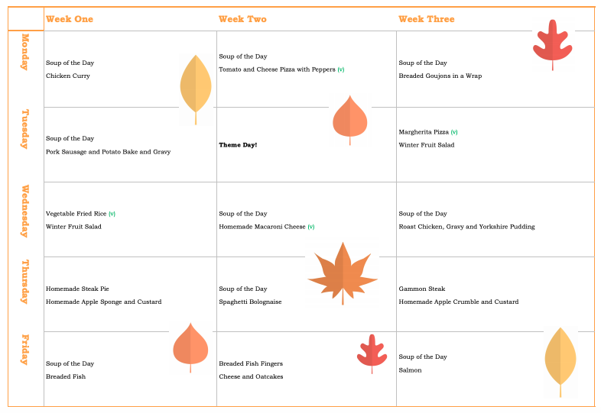
Our school catering team provide a two course hot lunch for children, free for all children. The menu for this is on a four-week rota; see an example of the menu below. If your child has/requires a special diet, please contact the school office and complete a Special Diet Request Form. If you prefer, you can provide your child with a healthy pack lunch instead.

We strive to provide a family atmosphere at meal times, where we encourage children to sit down with their peers, use cutlery, try new food and enjoy the mealtime experience.

OUTDOOR LEARNING

We encourage active, outdoor play and aim to be outdoors everyday, whether in our nursery garden or exploring the world around us. We provide waterproof clothing to be worn over your child’s own warm clothing and coat or jacket. We ask that you leave wellies and indoor shoes in nursery for daily use. We recommend that children wear clothes that are hard wearing and easily washed as they will be playing with paint, glue, glitter and mud! A change of clothing and underwear should also be brought to nursery each day in case your child gets wet, this can be kept in a bag that they bring to nursery.

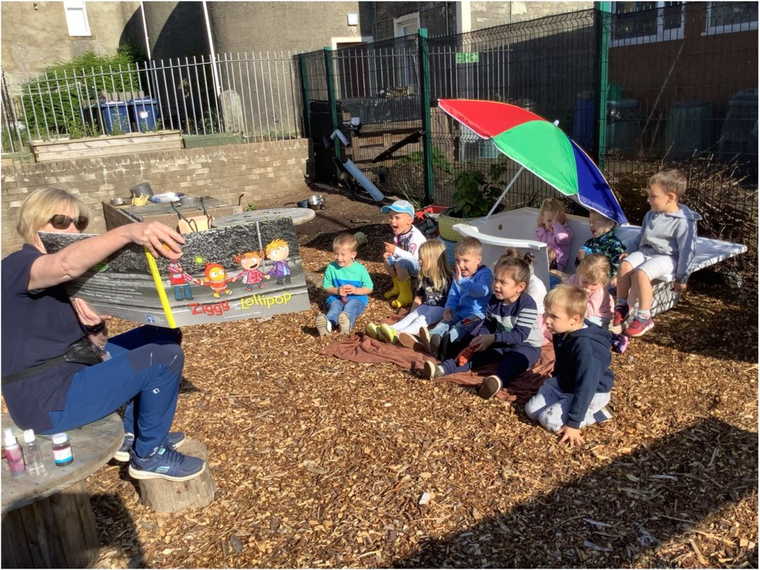
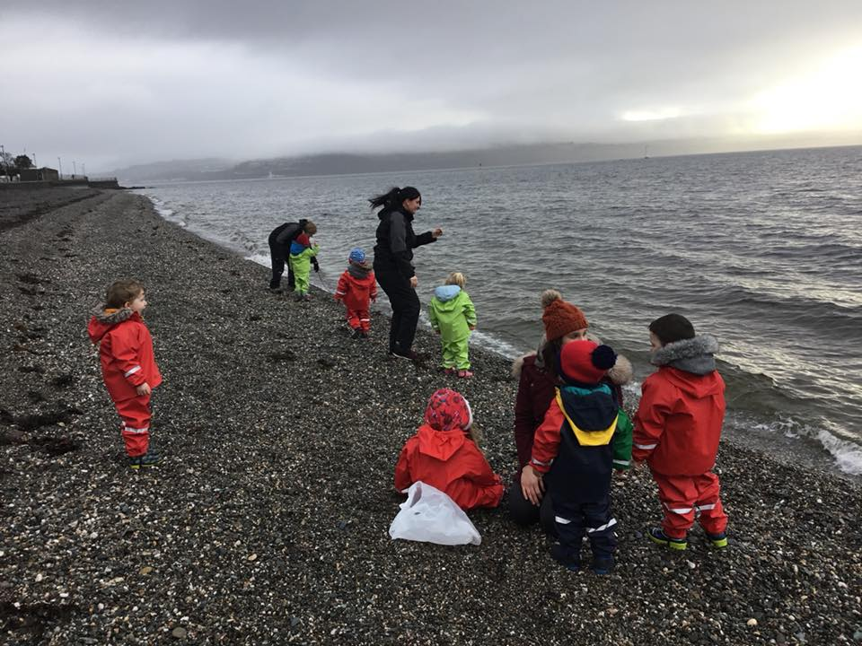

ATTENDANCE/ABSENCE

Please arrive promptly at the beginning of the session so that your child can start playing right away and get the most out of their learning. Also, collect your child promptly at the end of the session as your child will be excited to see you.
If your child will not be in nursery please phone the school office on the morning of the absence to give the reason. It is useful for staff to know if there is illness in the nursery that could easily spread. Following a period of sickness or diarrhoea your child should remain off nursery until 48 hours after the last bout of illness.

PARENT ENGAGEMENT/HOME LINKS

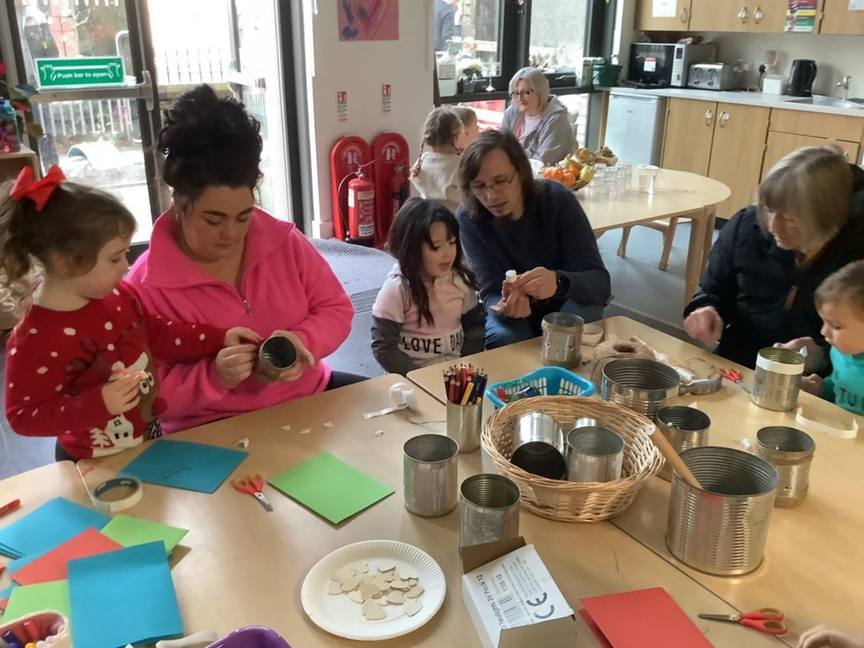
Before your child starts at Dunoon ELC you and your child will both be invited to visit the nursery and spend time in the playroom and outdoor spaces. You will get to meet your child’s key worker, nursery manager and the rest of the nursery team.
At Dunoon we actively encourage our parents to get involved in the activities of the ELC and also to share their skills and interests with the children. Parents are always welcome on trips and excursions too.

TRANSITION TO PRIMARY 1

Throughout your child’s time at Dunoon ELC they will have the opportunity to explore the wider school community; attending assemblies, end of term services, accessing the playground and Primary 1 classroom, to becoming an active part of the school.
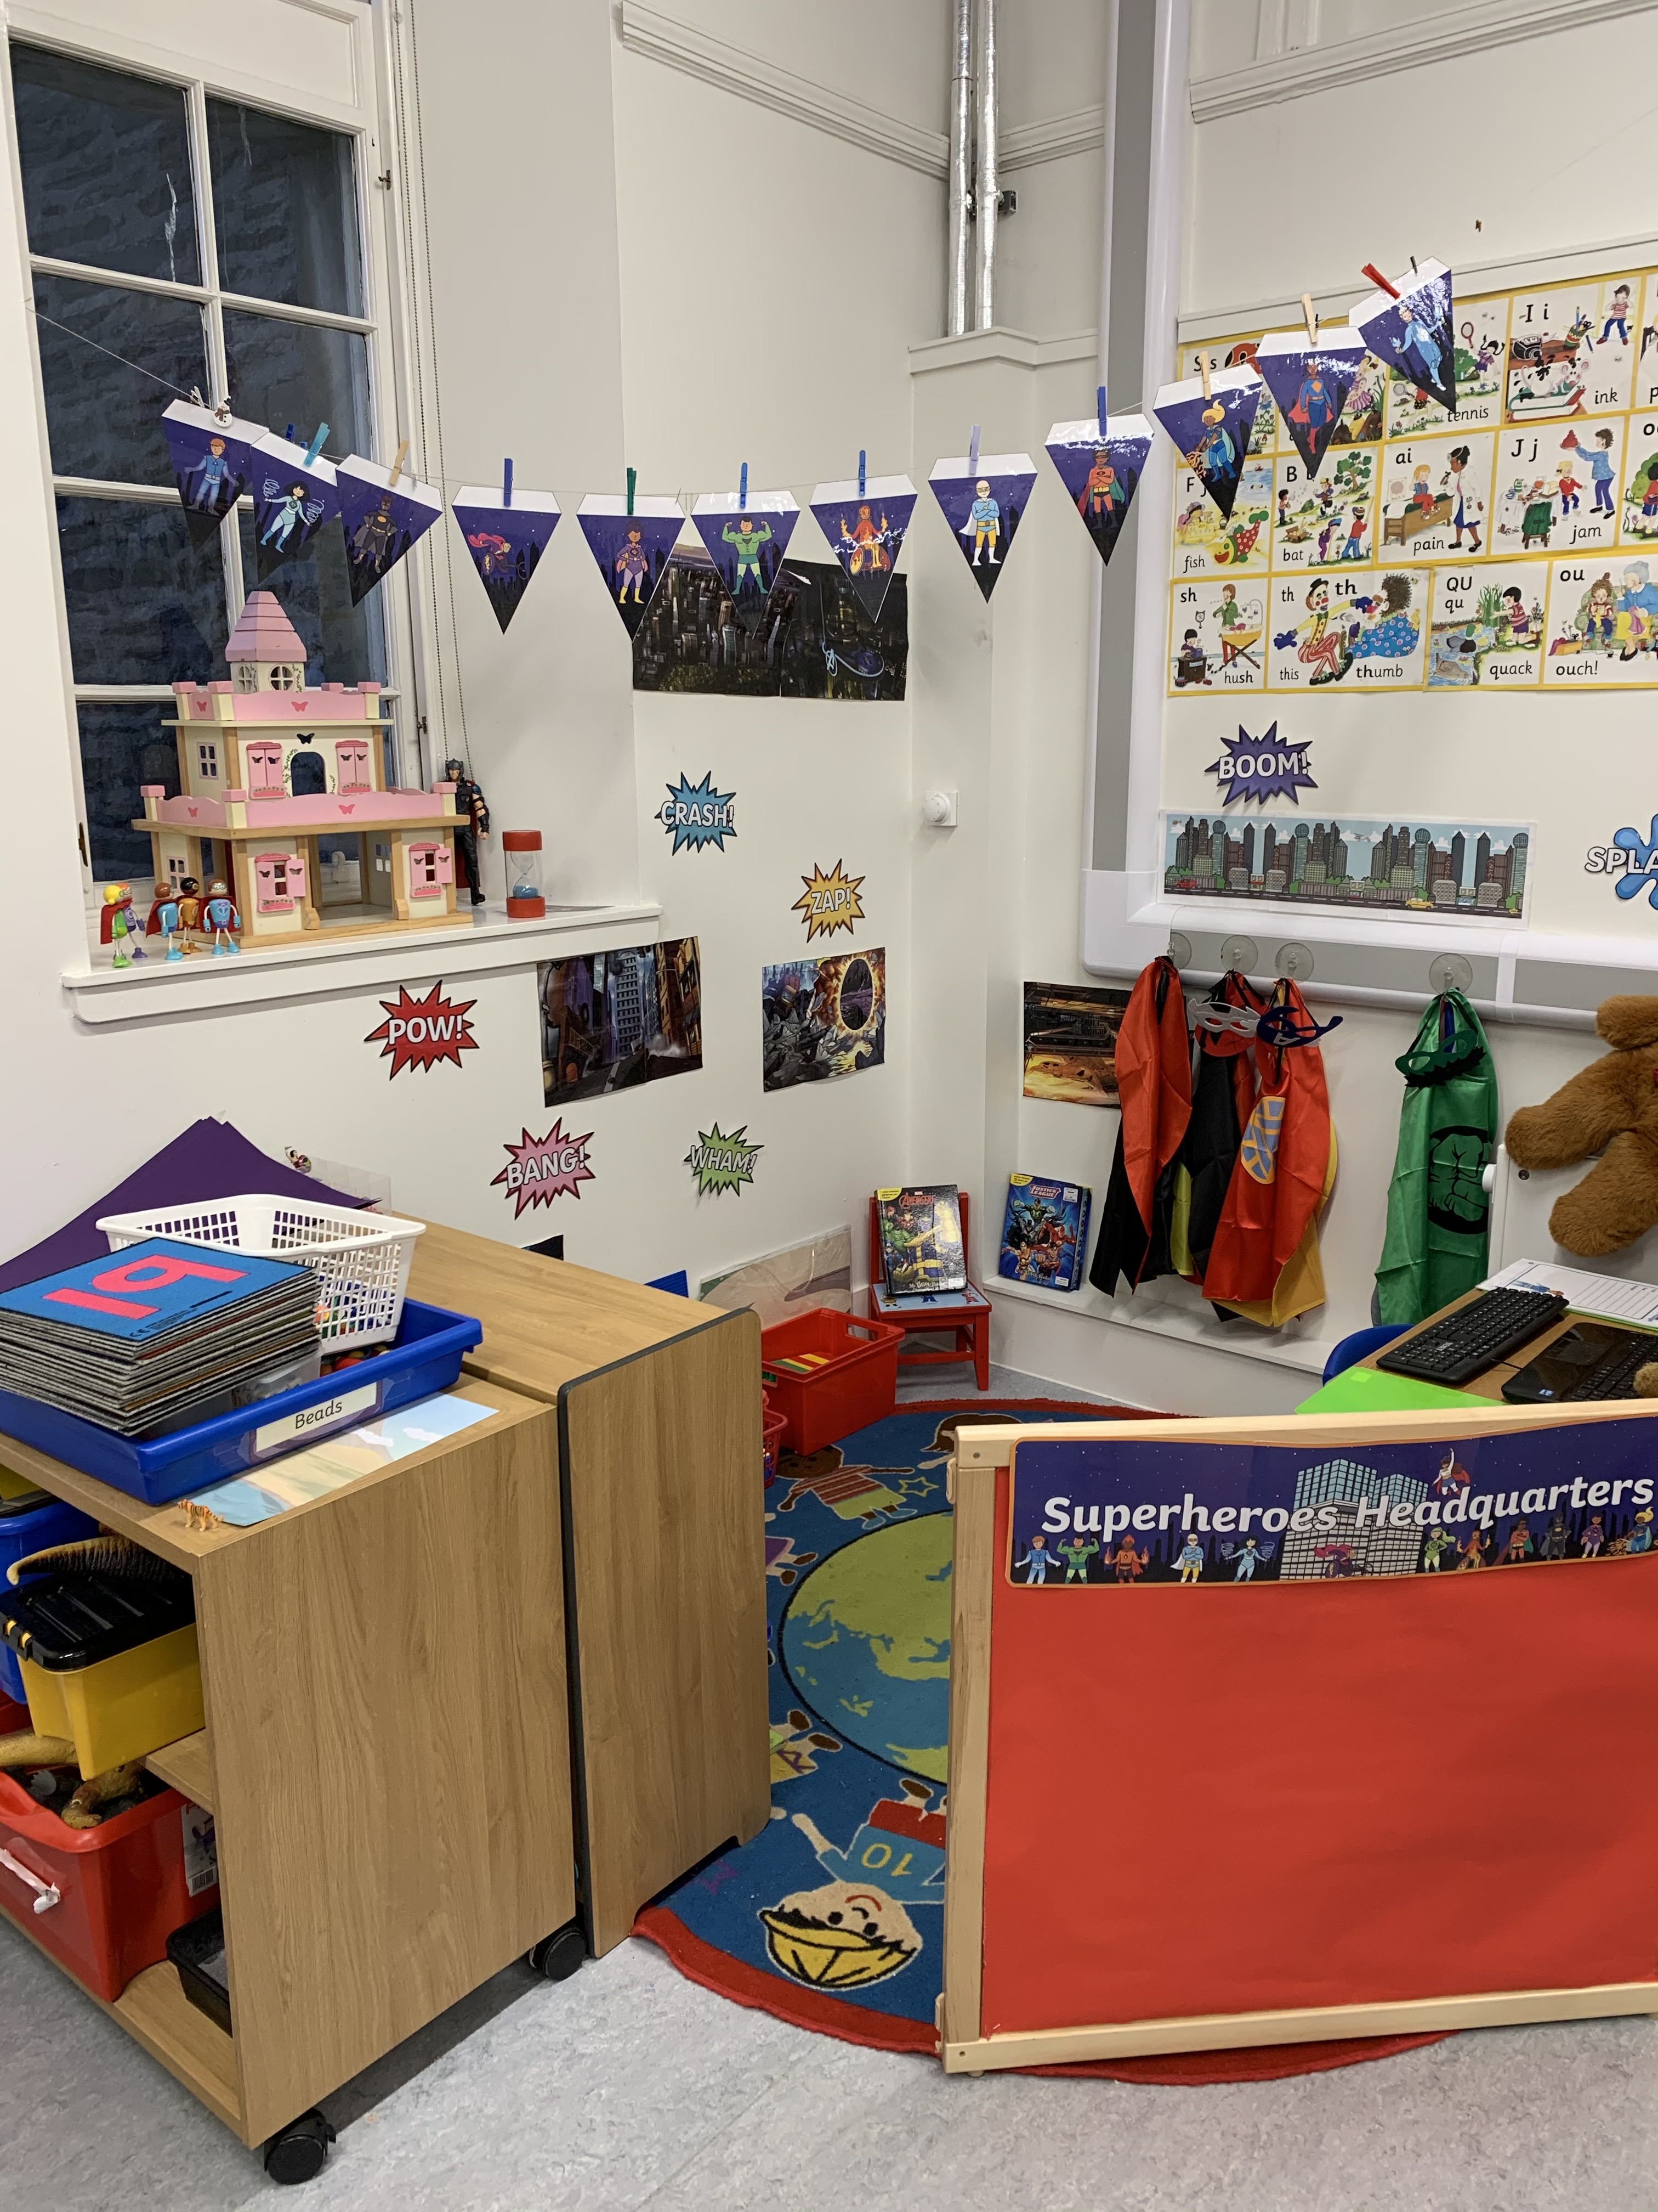
During the summer term, in your child’s pre-school year, there will be a series of events and visits to support your child’s transition into school.
The Primary 1 classroom is a continuation on from the nursery playroom. The children are taught actively through a play-based curriculum, which ensures a smooth transition from nursery into primary 1.

Complaints Procedure
Our intention is to work in partnership with parents and carers and we welcome suggestions on how to improve our setting at any time. We also appreciate hearing if there are comments or positive feedback that can be passed onto the team. This can be done through contacting the Principal Teacher by email, by phone or in person, or by speaking to one of the Nursery Team.
Complaints will be dealt with both professionally and promptly to ensure any issues arising from the complaints are handled effectively and to ensure the welfare of all children.
Complaint Procedure:
- In the first instance speak with either your child’s Key Worker or the Principal Teacher. The issues or concerns will be investigated thoroughly and a confidential written record of the meeting will be noted in addition to actions agreed.
- If the issue remains unresolved or parents feel they have received an unsatisfactory outcome, then these concerns can be raised with the Head Teacher of Dunoon Primary School:
Brenda Reid: brenda.reid@argyll-bute.gov.uk
we will acknowledge receipt of your complaint within three working days
we will confirm our understanding of the complaint
we will investigate and communicate what outcome you are looking for
we will try to resolve your complaint where we can (in some cases we may suggest using an alternative complaint resolution approach, such as mediation);
and where we cannot resolve your complaint, we will give you a full response as soon as possible, normally within 20 working days

If you decide to contact The Care Inspectorate regarding any concerns you may have about your child’s care or if you feel we have not handled your complaint appropriately the contact details are:
Care Inspectorate
Compass House
11 Riverside Drive
Dundee
DD1 4NY
Tel: 0345 600 9527
Email: enquiries@careinspectorate.com
www.Careinspectorate.com

OUTSIDE AGENCIES CONNECTED TO OUR SCHOOL & ELC

Health Visitor

Speech and Language Therapist

Occupational Therapist

Child Psychologist

Paediatrician

Social Work

Women’s Aid

Young Carers

Police

If you need any information about any of the agencies above please ask a member of staff or enquire at the school office.



